Luke Walsh and Chris Arancio
CSC485
Dr. Willwerscheid
Summary
Algorithm | Accuracy of total bases prediction | Correlation of predicted xwOBA with official xwOBA for every player (Adj. R^2 value)
XGBoost | 73.97% | 0.87986
KNN | 77.81% | 0.92614
GAM | 77.23% | 0.9212

Correlation Graphs
XGBoost:
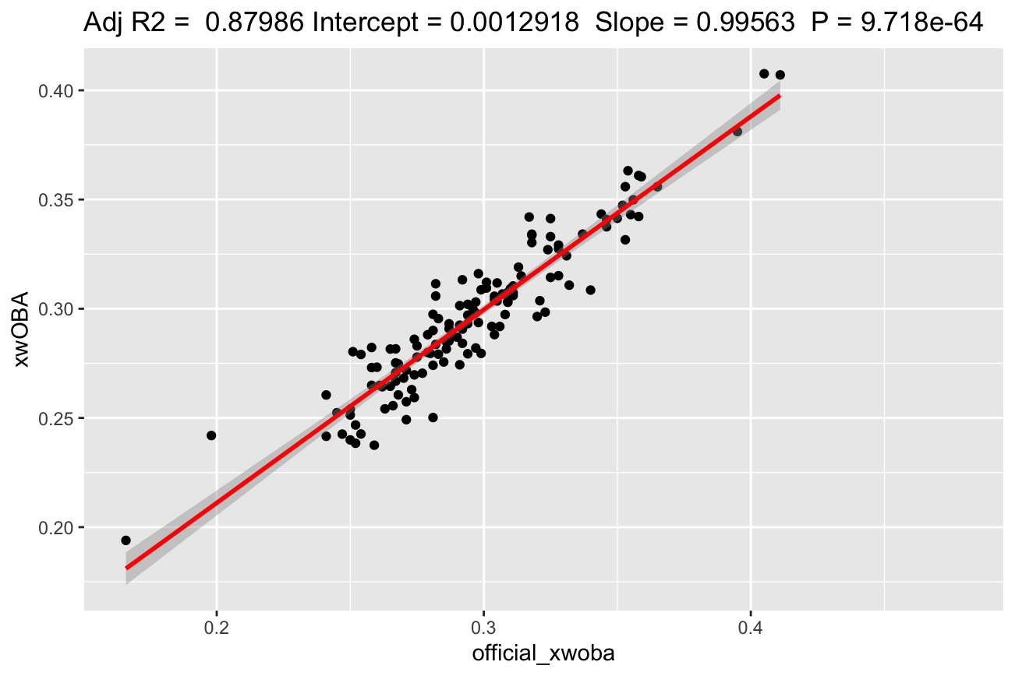
KNN:
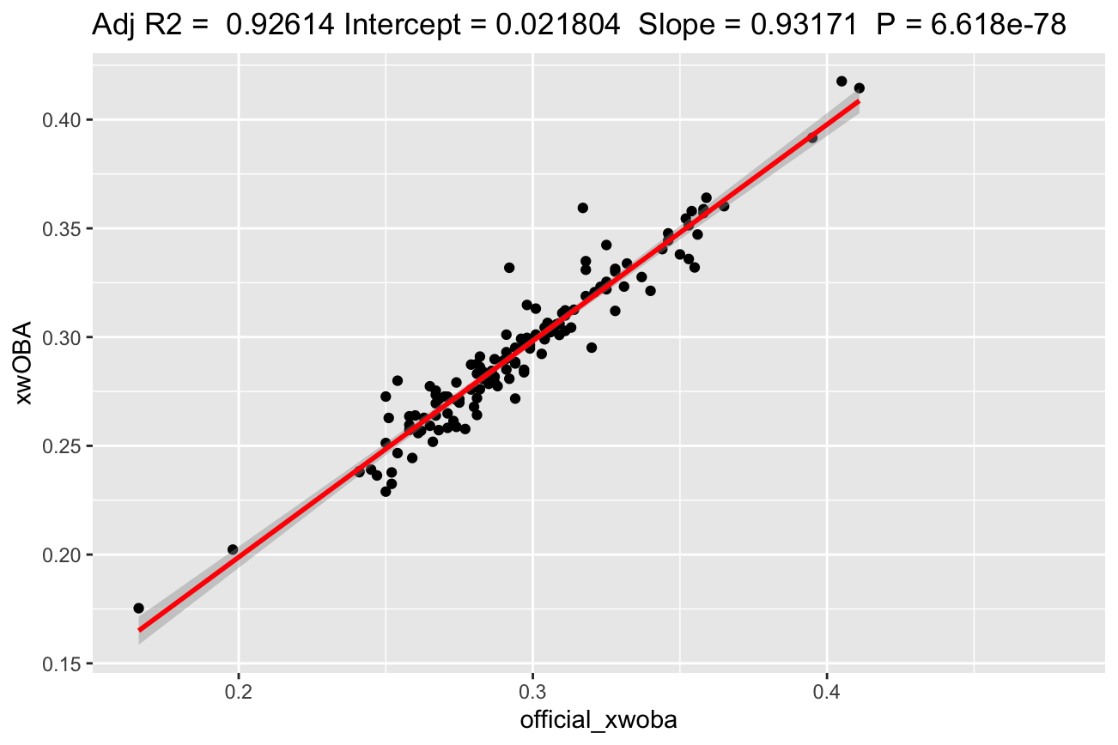
GAM:
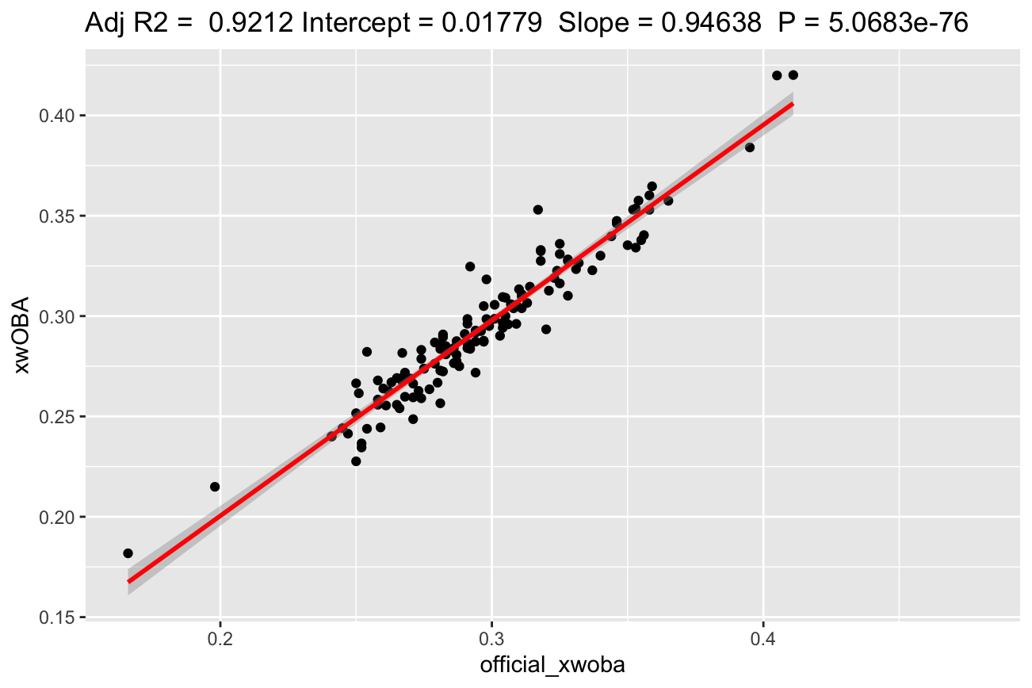
xwOBACON Gradient Maps
XGBoost:
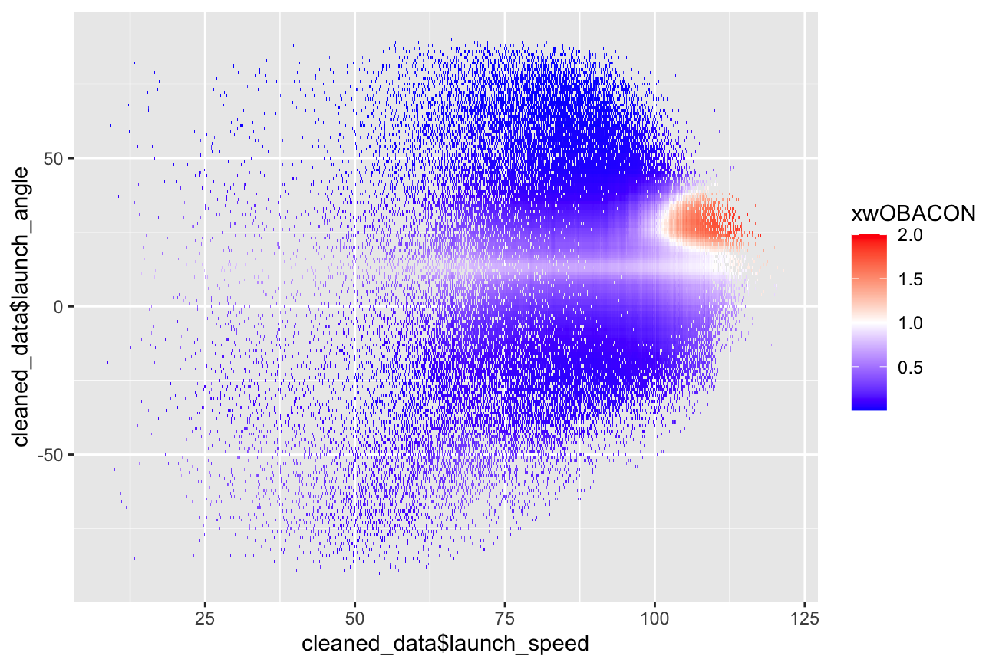
KNN:
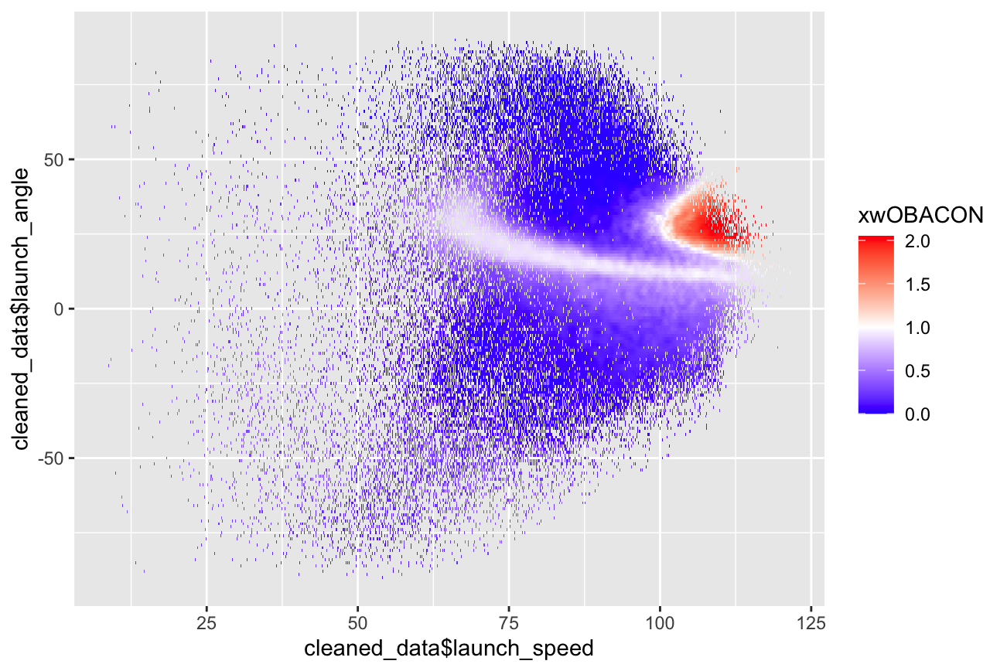
GAM:
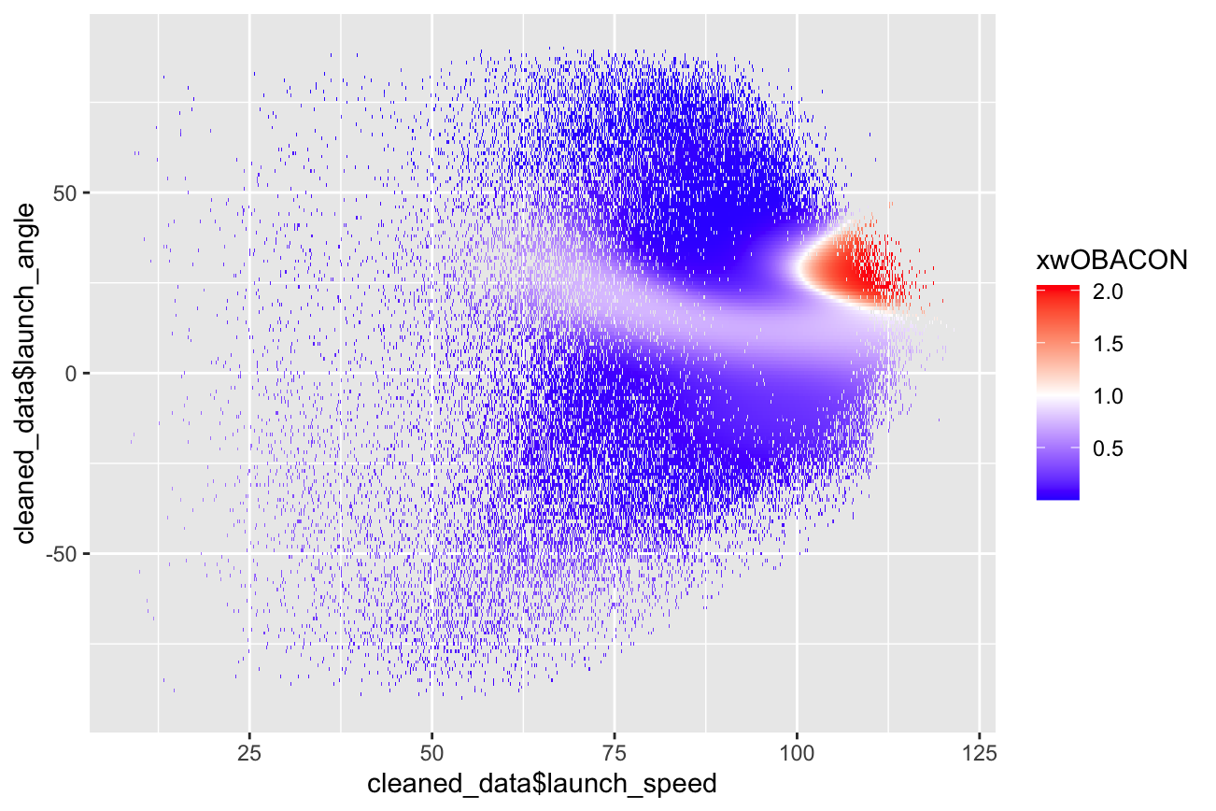
Statcast Comparison:*
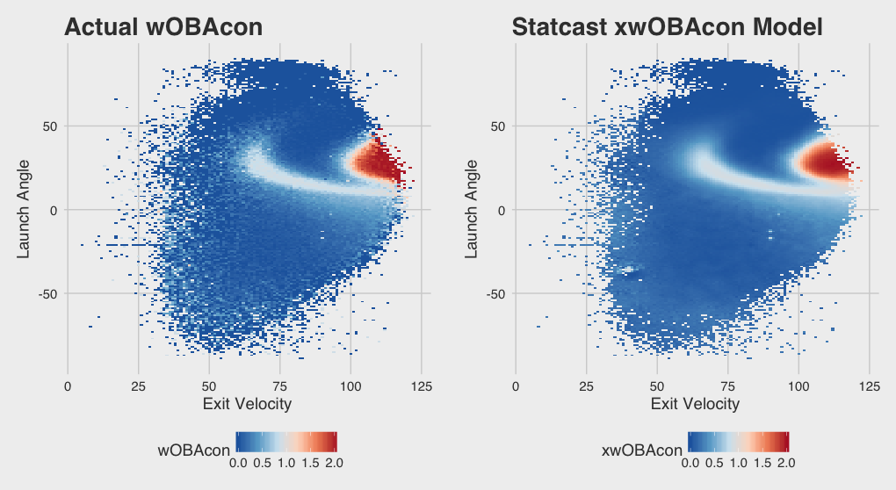
*These final graphs are provided here by Sam Sharpe for the MLB Technology Blog. They serve as a nice comparison to our graphs where it seems like KNN produces the most similar results.

